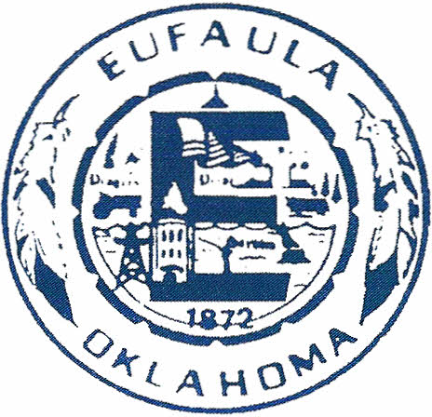
City of Eufaula
P.O. Box 684
Eufaula, Ok. 74432
PHONE (918) 689-2534

Dear Eufaula Business Owner/Manager,

Please join the Roger Brooks results presentation on his community assessment. Through the generosity of donations, the City was able to contract with Mr. Roger Brooks to conduct a community assessment through the eyes of a visitor/tourist. Mr. Brooks is an expert in the fields of tourism, community branding, downtown development, and destination marketing. Over the past 30 years, he has helped thousands of people transform ordinary places, businesses, and attractions into incredibly successful destinations. Closer to home, Mr. Brooks has conducted the community assessment and assisted the cities of Tahlequah, Muskogee and Okmulgee.
Mr. Brook’s presentation and insights are intended to provide Eufaula with ideas for local businesses and the community, to increase spending, repeat visits, and to make Eufaula an Oklahoma showcase community.

September 2, 2016 from 8:00 am – 12:00 pm will be Mr. Brooks’ report on his secret shopping experiences. In addition, he will provide a presentation on community branding and discussion on where do we go from here.

Please plan on joining me and other community businesses on September 2, 2016. We understand your time is valuable and if you cannot commit to the full four hours, please try to make the first part starting at 8:00 am, which will be his report and recommendations.

Thank you for your time and operating your business in the great City of Eufaula.

Sincerely,

J. Gregory Buckley
City Manager

